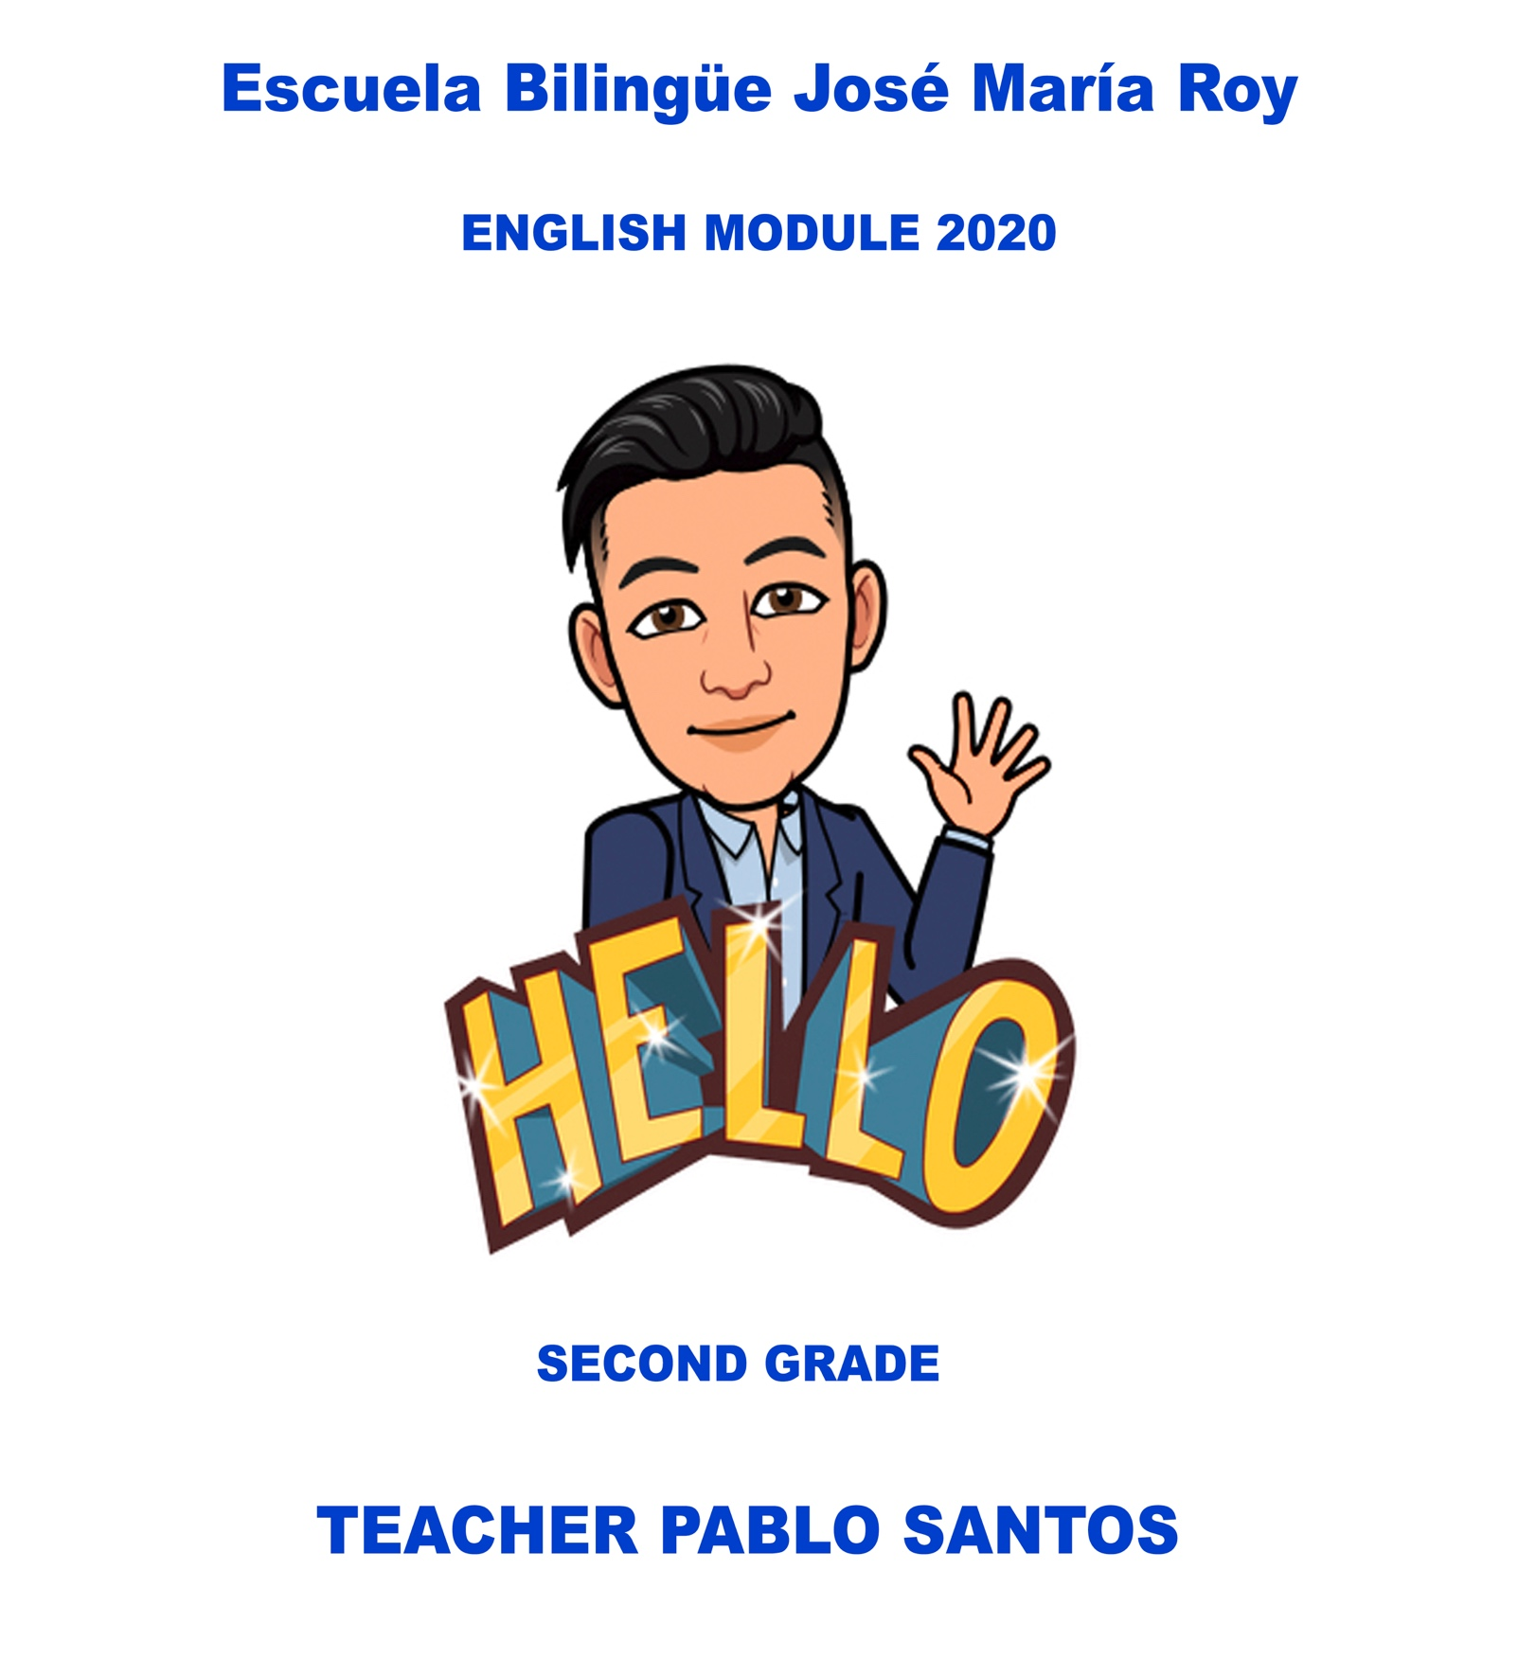
Student: ____________________________

Introduction

English language is one of the most important languages in the world, it is necessary to communicate with people from different cultures, ethnicities and countries.
English is also essential for education. In many countries, children are taught and encouraged to learn English as a second language. Almost 90% educational subjects are written in English. Number of scientific innovations and books are written in English Language.
English is also essential for education. In many countries, children are taught and encouraged to learn English as a second language. Almost 90% educational subjects are written in English. Number of scientific innovations and books are written in English Language.
This module is a collection of classes, workshops, readings and relevant material related to the units of the book “BIG ENGLISH” to help students at home due to the crisis that we are having in Panama with COVID-19.

CONTENT

- Special days
- Months of the year.
- Birthday Celebration
- Hot and cold food
- Toys and colors
- Sport and games
- Numbers
- Prepositions of place
SPECIAL DAYS
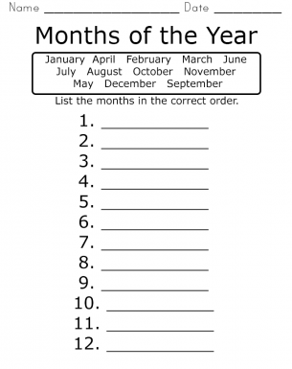

WORD SEARCH
MONTHS OF THE YEAR

- Try to find all the hidden words about the months of the year.
- Remember words can be diagonal, vertical or horizontal. Good Luck!
- Write them in the lines.
- Keep your work neat.

- _______________________
- _______________________
- _______________________
- _______________________
- _______________________
- _______________________
- _______________________
- _______________________
- ______________________
- ______________________
- _______________________
- ____________________

THINK ABOUT IT!
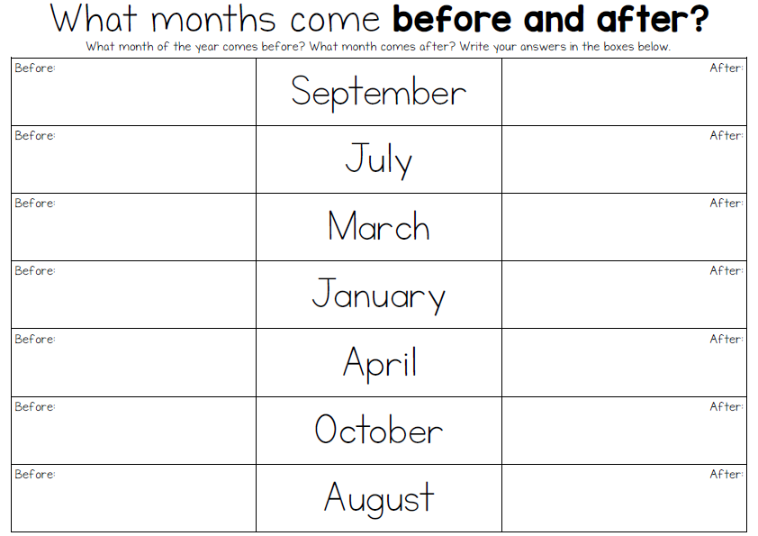

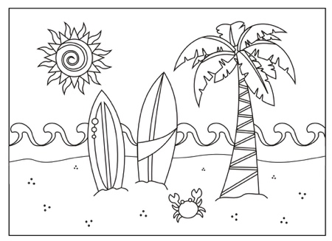
JANUARY

- Make a list of favorite summer things to do.
- Make a list of favorite places to go in the summer.

Favorite Summer Things to Do | Favorite Places to Go
1. | 1.
2. | 2.
3. | 3.
4. | 4.
5. | 5.

RACTICE

Write a special day for each month.

Months | Special Days
March

April

May

June

July

August

September

October

November

December

Draw and write a sentence to describe your favorite special day.

___________________________________________________________________________________.
PARTY TIME

- Learn the next vocabulary about Birthday Party
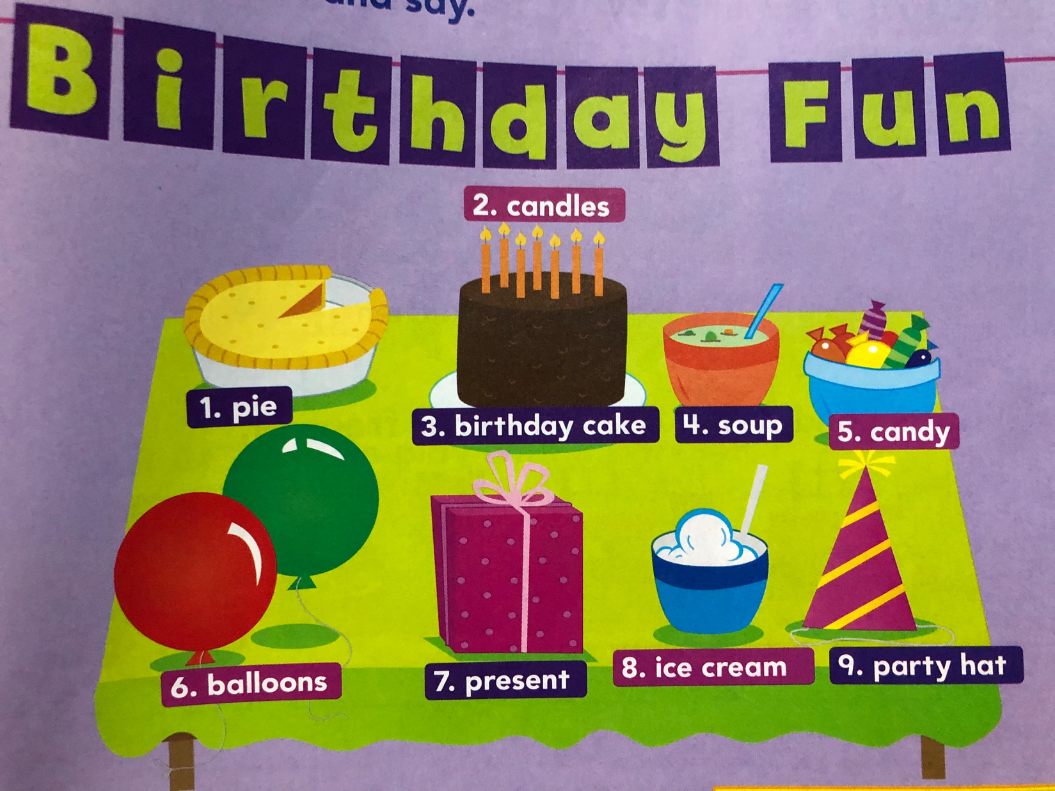
- Say and repeat it twice.
- Practice the pronunciation with your parents.

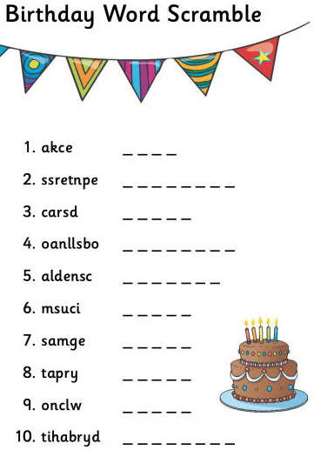

Order the letters and create words related to a Birthday Party

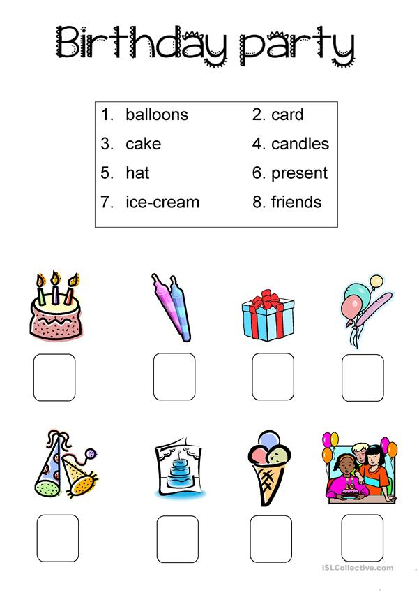
Write the correct number in the correct picture
- Write the numbers in the correct picture

CELEBRATE

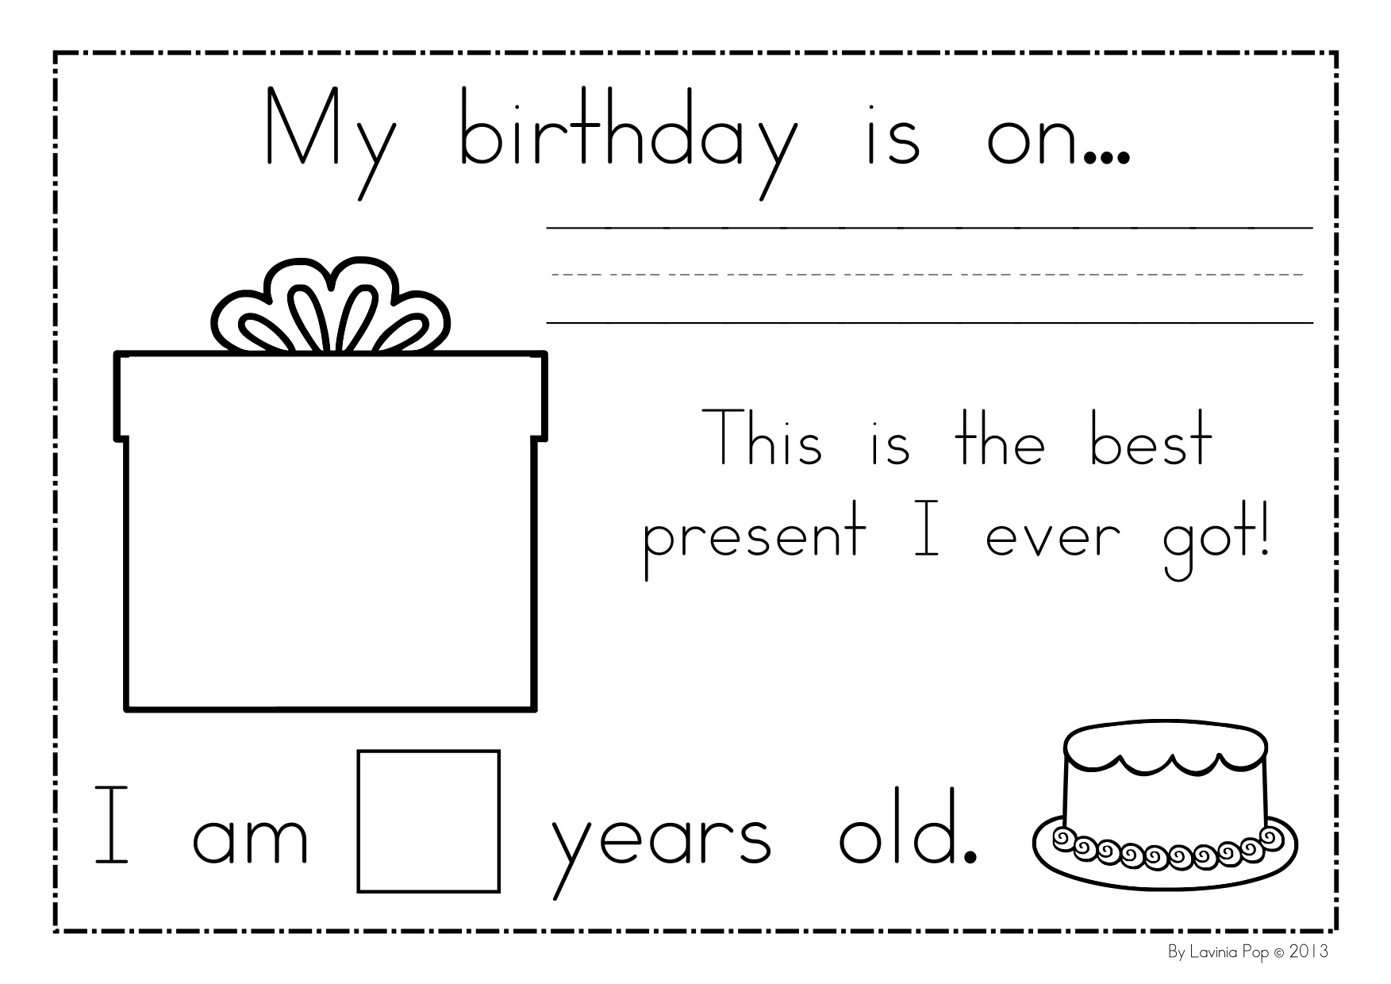
- Tell us about your Birthday.

- Draw your ideal Birthday Party

Reading time

- Read and analyze the next Story
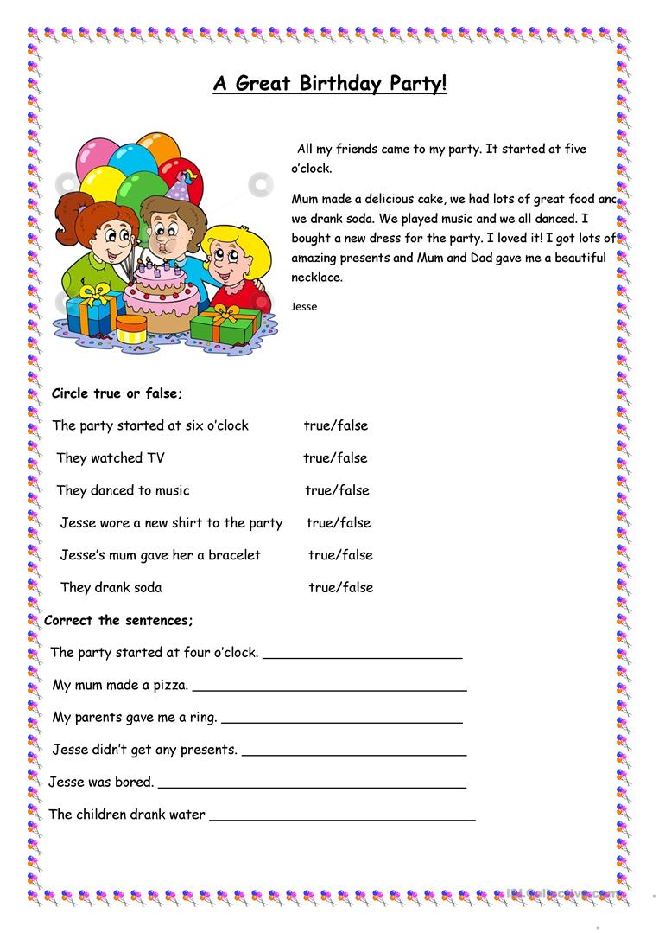

HOT AND COLD FOOD

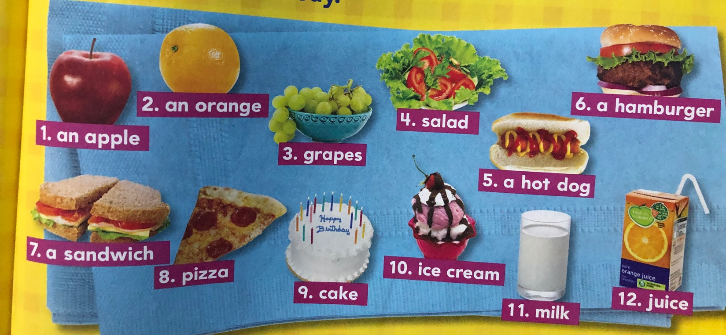
- Point and Say

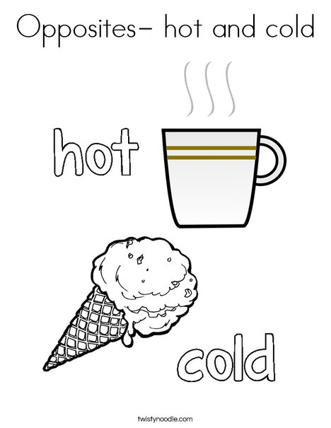
EXAMPLE:

- Write 5 hot food and 5 cold foods by writing them in the correct column. Use the pictures from the previous page or add more. (you can write drinks too)

HOT FOOD | COLD FOOD

- Draw one hot food and one cold food you like. (You can use drinks too)

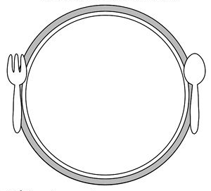

PROJECT

- MAKE A BIRTHDAY INVITATION CARD USING MATERIALS. BE READY TO PRESENT IN CLASS.
- MATERIALS:
CONSTRUCTION PAPERS.
GLUE
SCISSOR
STICKERS
PICTURES
PHOTOS
FOAMY

- WRITE ABOUT THE DATE, PLACE, YOUR NAME, ETC
- EXAMPLE
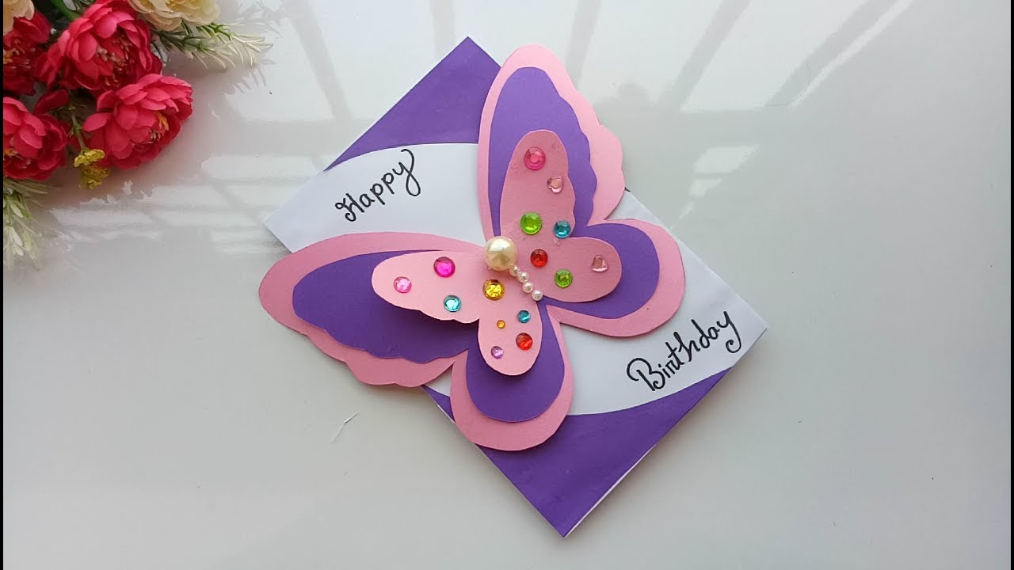

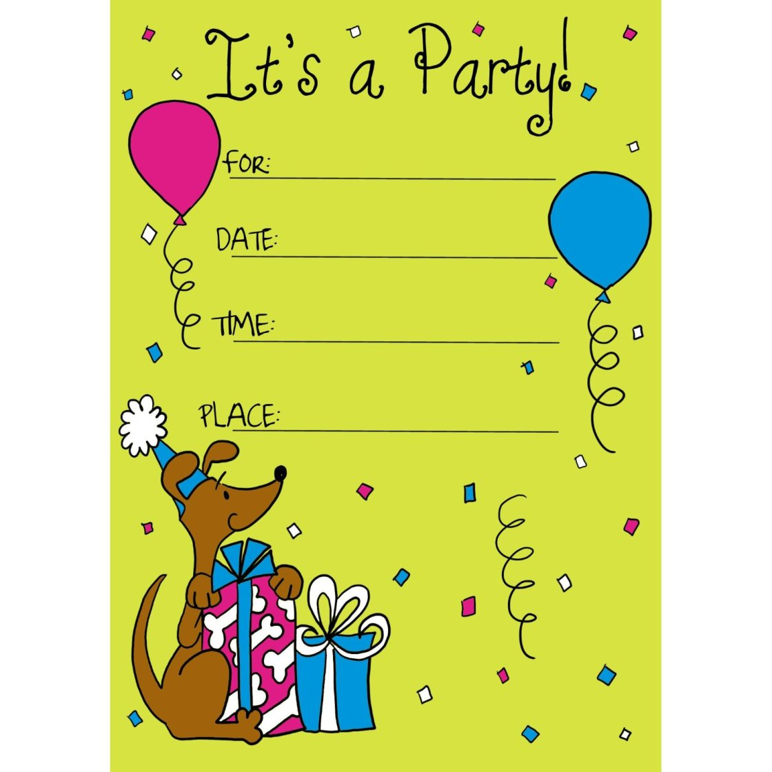

BIRTHDAY INVITATION CARD RUBRICS
 | Exceeds Standard (5 Points) | Meets Standard (3 Points) | Below Standard (1 Point)
Text & Language | Text complements and strengthens the holiday, colors, and images on the card. | Text is appropriate for the holiday, colors, or images on the card. | Text does not match the holiday, colors, or images on the card.
Colors & Images | There is a strong connection between the colors on the card and the holiday, text,  and images. | Colors are appropriate for the holiday, text, or images on the card. | Colors do not make sense with the holiday, text, or images on the  card.
Quality | The card shows conscientious, careful work and attention to detail. | The card shows thoughtful work. | The card shows sloppy or hurried work.
Creativity | The project shows excellent creativity in design. | The project shows average creativity in design. | The project shows moderate creativity in design.
Comments: _________________________________________________________________________________________________________________________________________________________________________________________________.

First Unit Evaluation

Name: _____________________ Date: ___________________ Level:________________ Total: /50

CRITERIA | 10-7 | 6-4 | 3-2 | 1-0
Responsibility
Follow directions
Neatness
Writing
Content

This Unit has an evaluation of two grades.

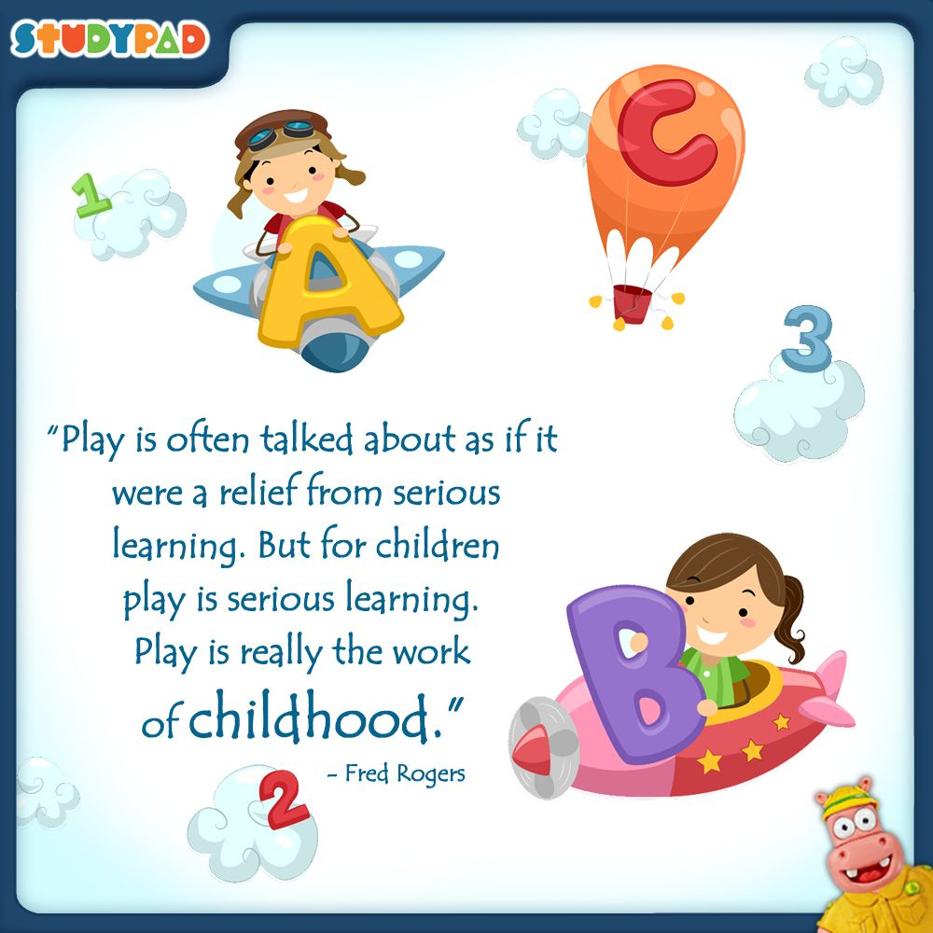

My Toys

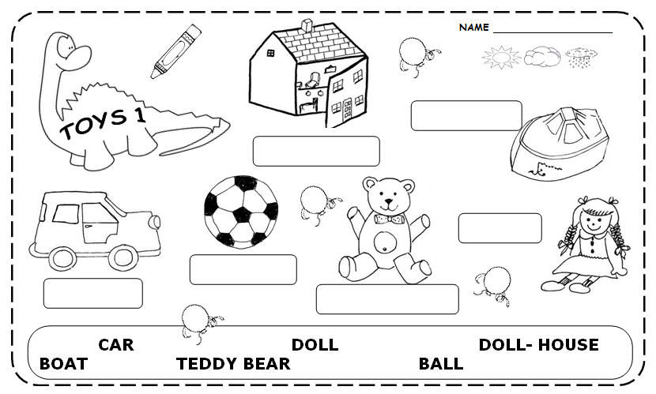
Write the correct name of each toy and color

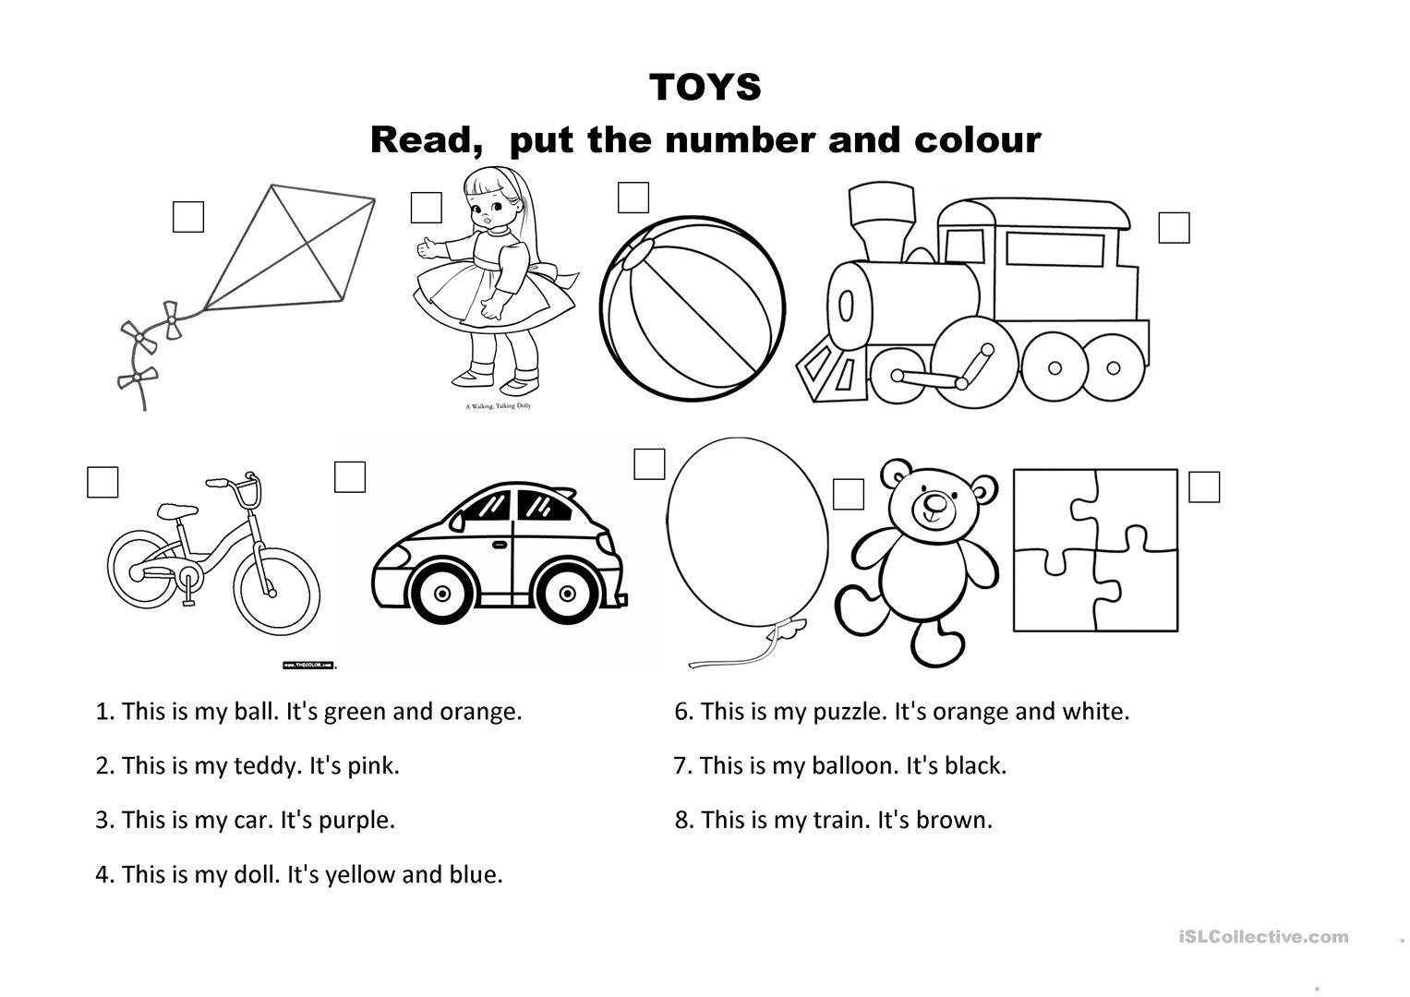

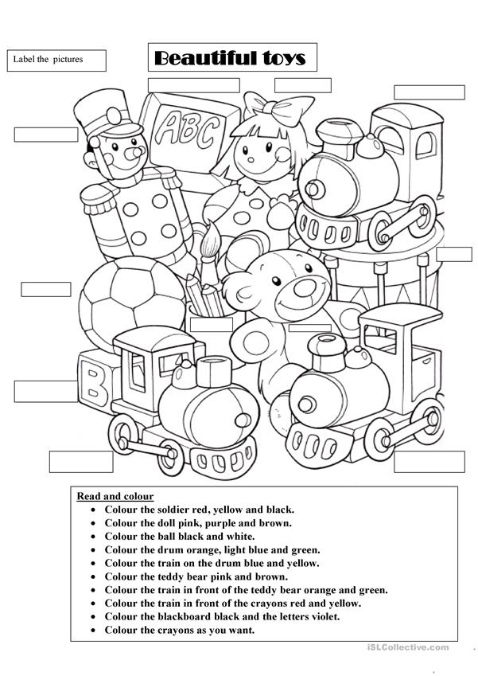

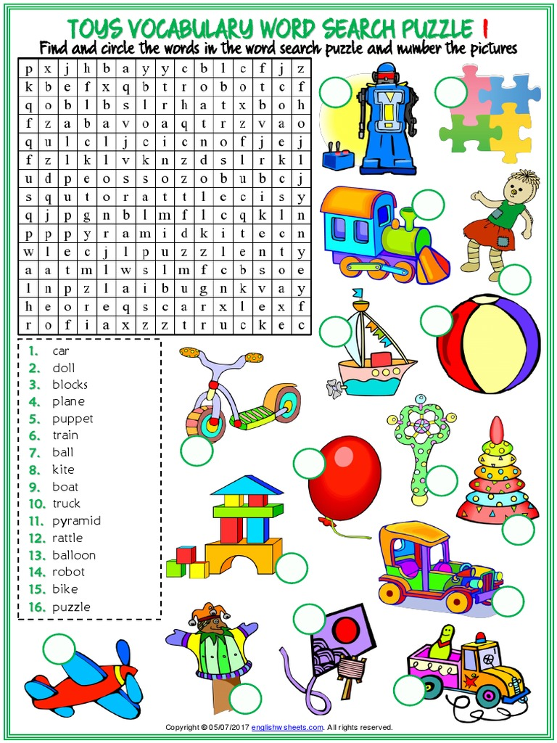

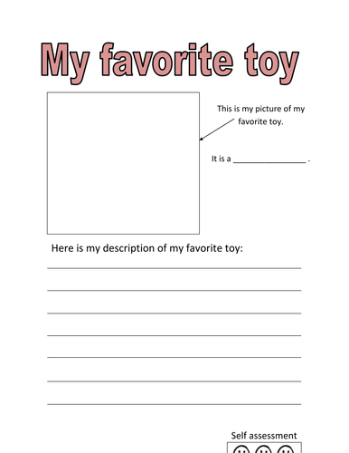
Tell us about your favorite toy
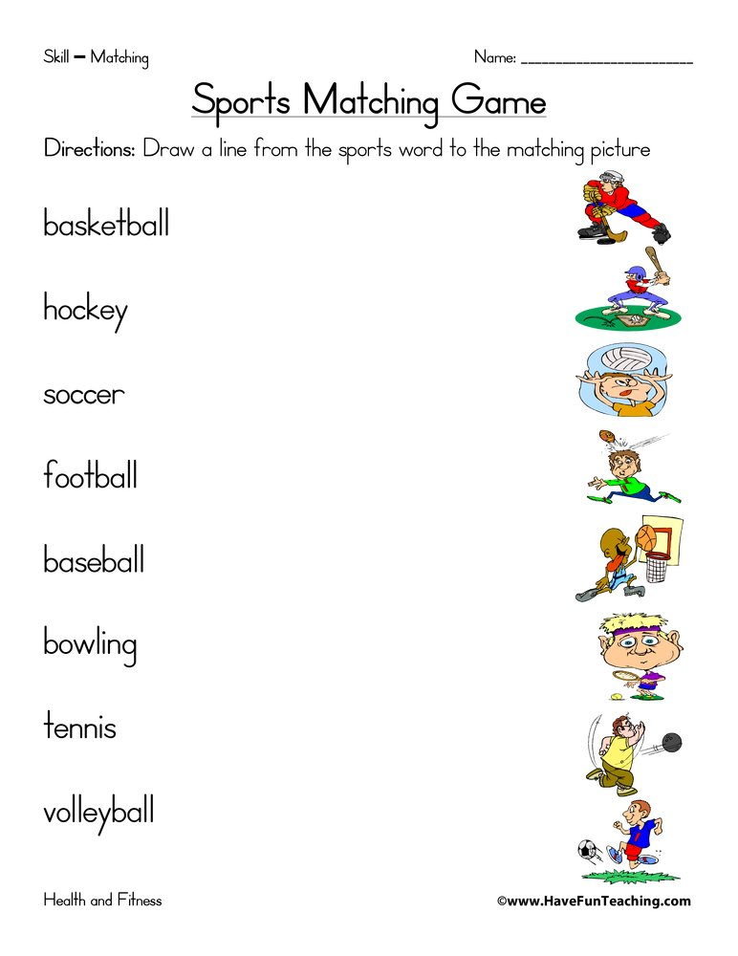

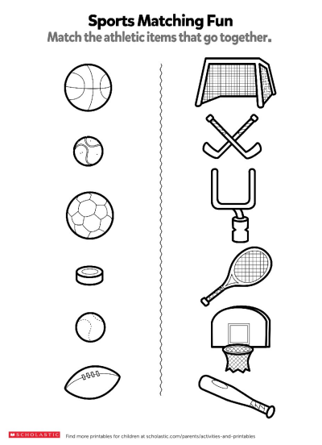

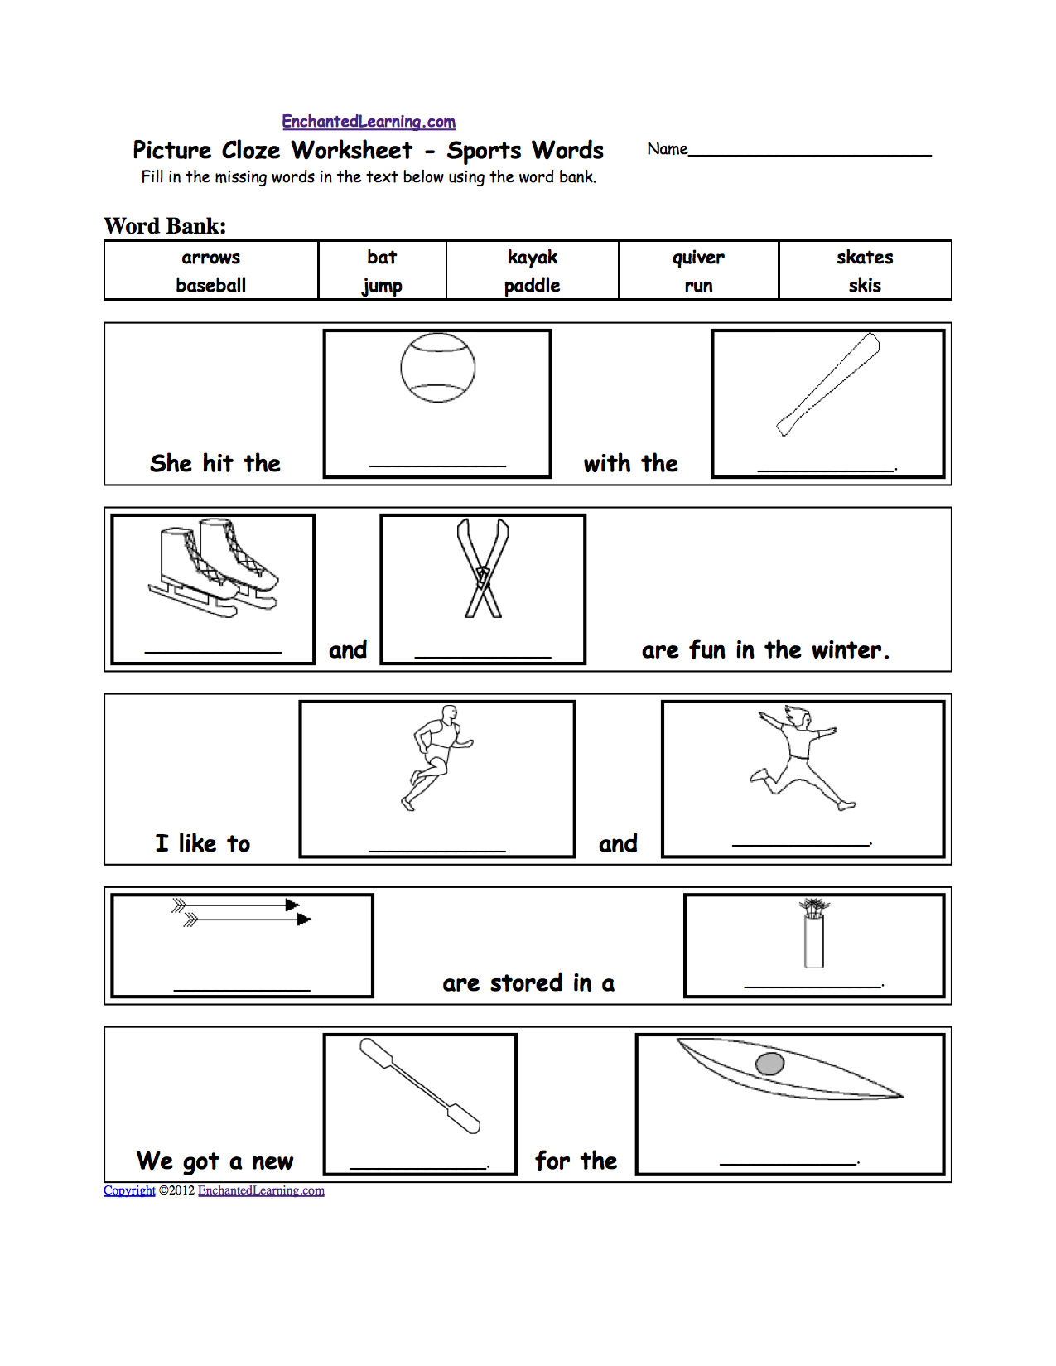

Learn the numbers in words
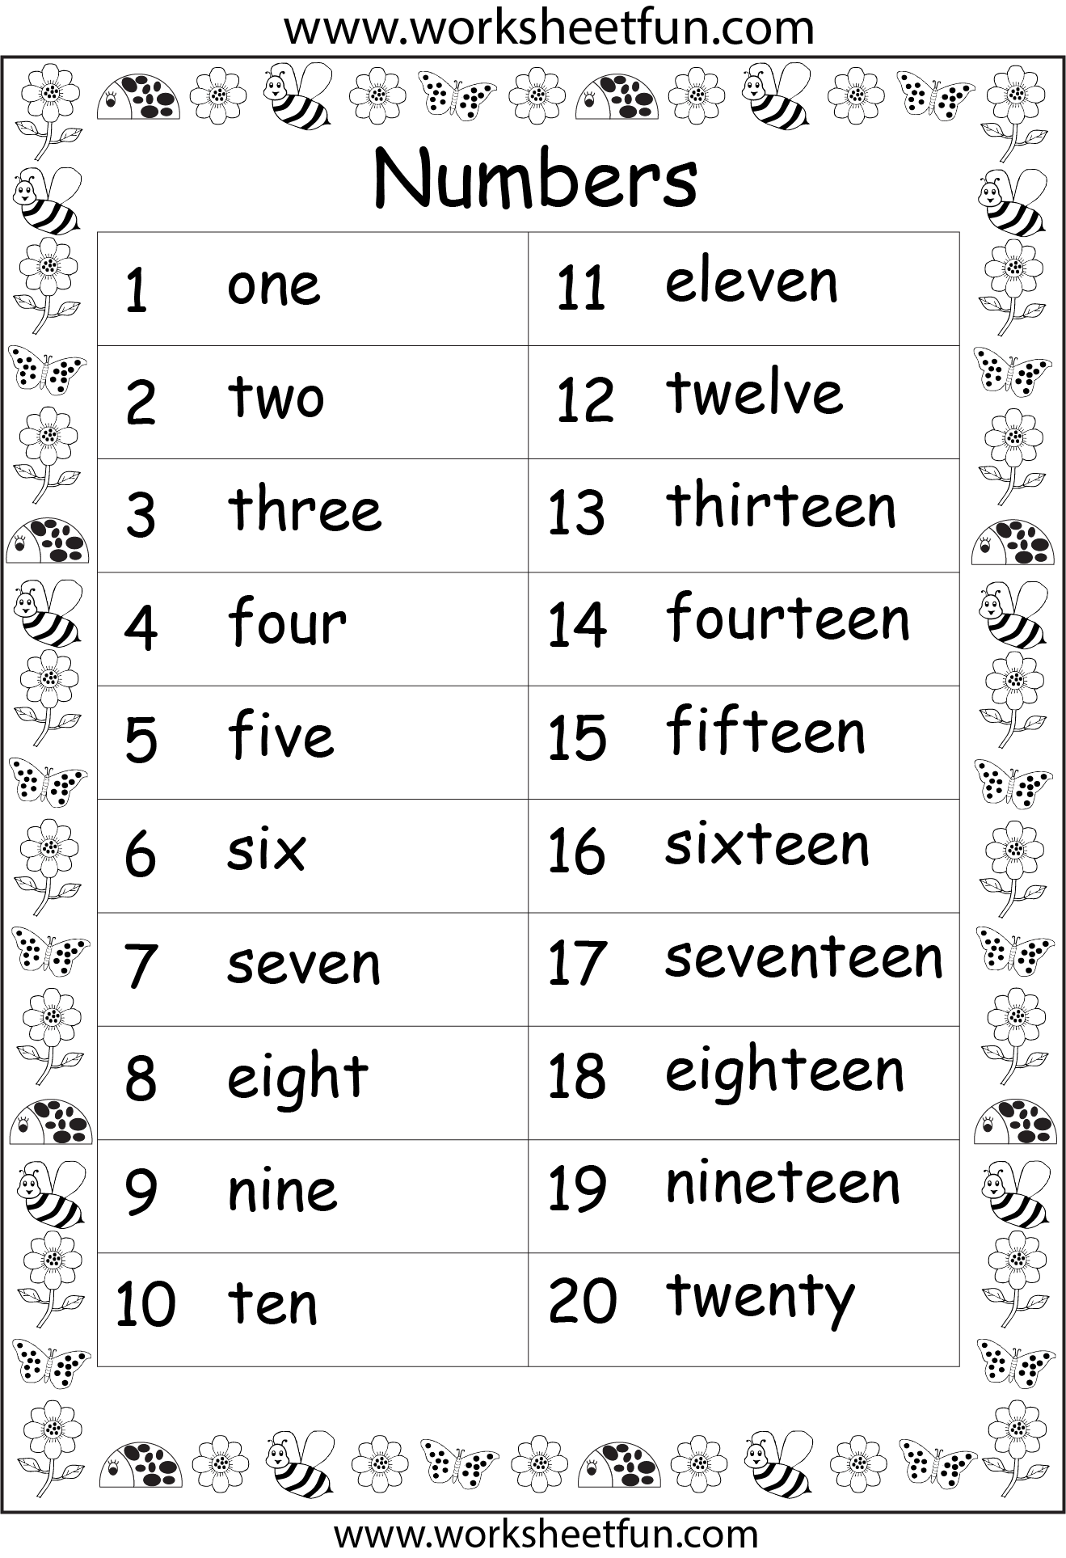

- Count and color each toy.
- write the numbers in words.
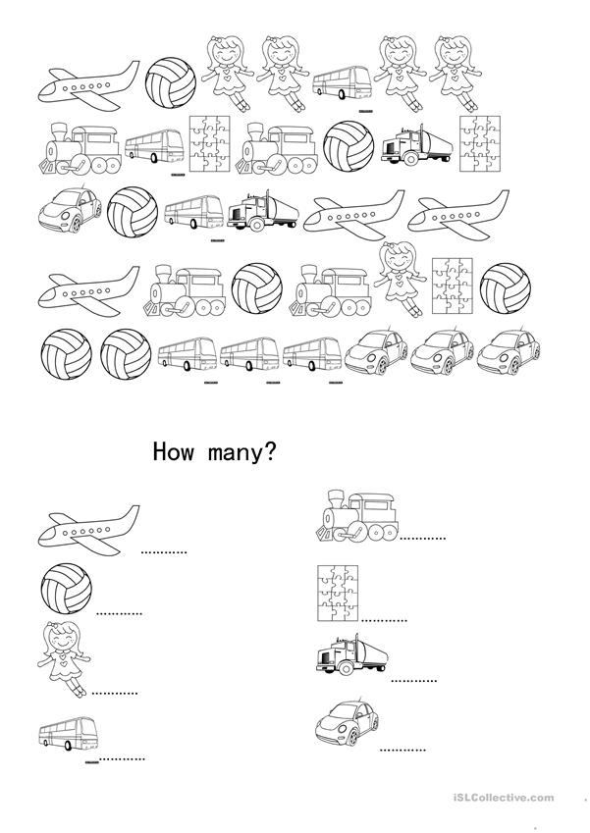

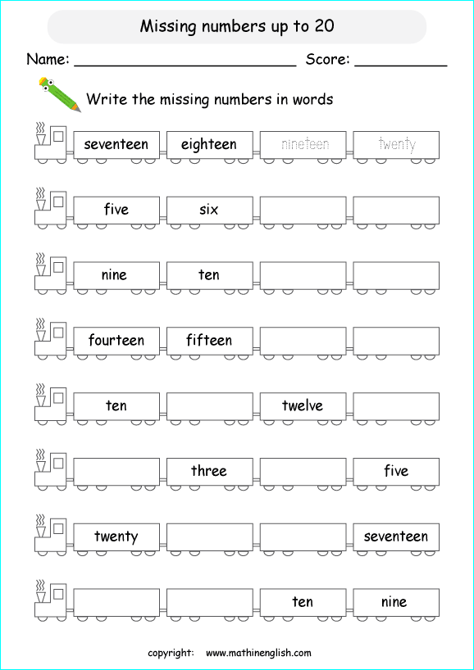

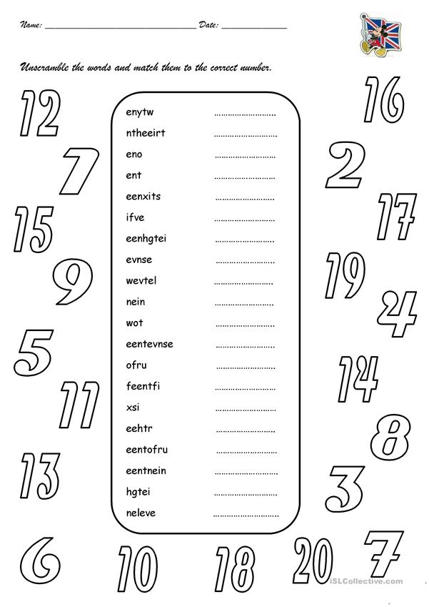

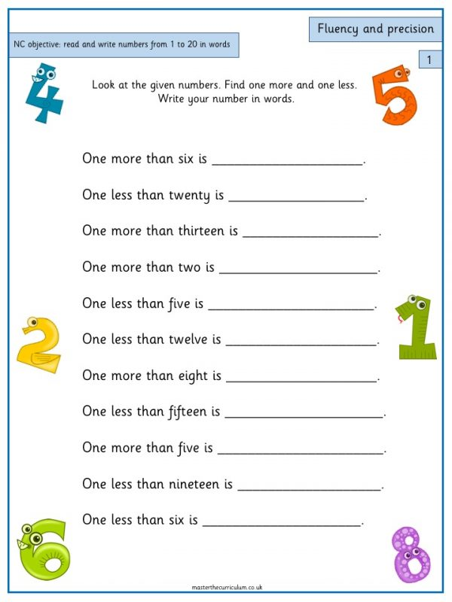
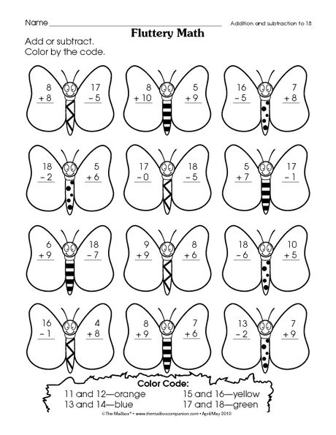

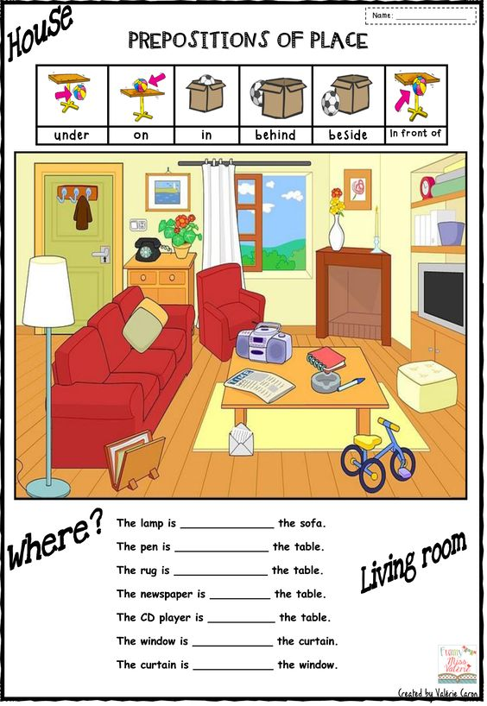

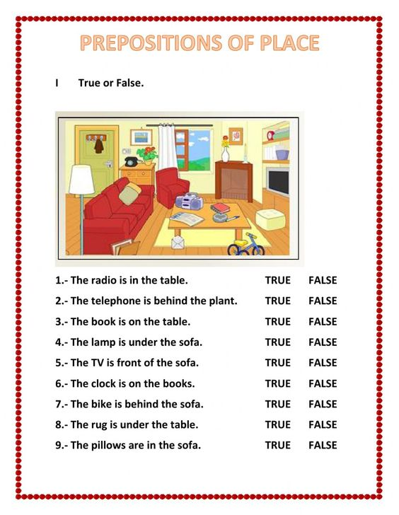
Project
*Make a poster about your favorite game by following the example.
*Answer the questions about your game and follow the directions in the example.
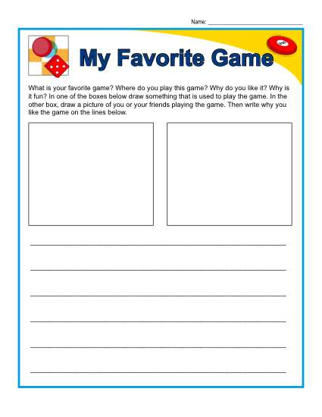
* Decorate your poster according to your game. Be creative
*Be ready to present in class

My favorite Game Rubric

Date____________________________
Teacher_________________________

Student name ________________________

 | Exceeds Standard (5 Points) | Meets Standard (3 Points) | Below Standard (1 Point)
Text & Language | Text complements and strengthens the game, colors, and images on the poster. | The text answers the questions appropriately from the game, the colors and the images on the poster. | Text does not match the game, colors, or images on the poster.
Colors & Images | There is a strong connection between the colors on the poster and the game, text,  and images. | Colors are appropriate for the game, text, or images on the poster. | Colors do not make sense with the game, text, or images on the  poster.
Quality | The poster shows conscientious, careful work and attention to detail. | The poster shows thoughtful work. | The poster shows sloppy or hurried work.
Creativity | The project shows excellent creativity in design. | The project shows average creativity in design. | The project shows moderate creativity in design.
Effort | The student gave on effort beyond the requirements of this project | The student finished the projects, but it locks finishing touches or can be improved with a little effort. | The student did not finish the work in satisfactory manner.

Total points earned ____________

Teacher Comments:

Second Unit Evaluation

Name: _____________________ Date: ___________________ Level: ________________ Total: /50

CRITERIA | 10-7 | 6-4 | 3-2 | 1-0
Responsibility
Follow directions
Neatness
Writing
Content

This Unit has an evaluation of two grades.

